Circle the correct answer.
- There is/are cats in the kitchen.
- There is/are mum and dad in the living room.
- There is/are flowers in the vase upstairs.
- There is/are everybody in the shopping centre.
- There is/are students in the classroom.
- There is/are an interesting article in the today’s newspaper.
- There is/are some people who don’t care about their education.
- There is/are a bath in my bathroom.
- There is/are many books in the library.
- There is/are a hamster downstairs.
Fill in the blanks with THERE IS/ THERE ARE.
- ……………….. frogs in the pond.
- ……………….. children at school.
- ……………….. one pen in my pencil case.
- ……………….. women in the shop.
- ……………….. a rabbit in my garden.
- ………………… a fridge in my kitchen.
- …………………. four lamps in the living room.
- ………………….. some crisps in the bag.
- …………………… men in the company.
- ……………………. a noise coming out of this room.
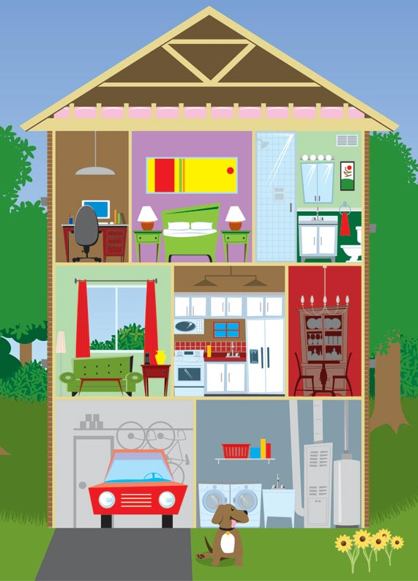
According to the picture fill in the blanks with there is/ there are/ there isn’t/ there aren’t.
- ………………….. a car in the garage.
- ………………….. five chairs in the living room.
- ………………….. one bed in the house.
- ………………….. two dogs outside.
- …………………... two lamps in the bedroom.
- …………………… curtains in the living room.
- …………………… a fridge in the kitchen.
- …………………… two computers upstairs.
- …………………….one chair in the dining room.
- …………………… a bath in the bathroom.
- …………………….a bike in the garage.
- …………………… flowers outside the house.
- …………………… a window in the kitchen.
- ……………………. one cupboard in the kitchen.
- …………………… two tables in the living room.

